Sumter Dialogue - Feb 29, 2020, 1pm – 3:30pm
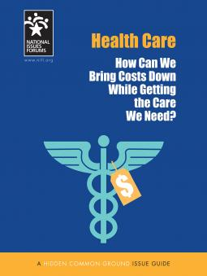
Near the: Holy Comforter Church
Barr
Learning Center
(nea
207 North Main St.
Sumter,
South Carolina, 29150
Health Care 2020, Call: 803-968-0388 for info.
How Can We Bring Costs Down While Getting the Care We Need?
High health-care costs affect all Americans, often in deeply personal ways. This guide is designed to help people deliberate together about how we should approach the issue. It suggests three options for deliberation, along with the trade-offs each might involve. Each option presents advantages as well as downsides. Each raises questions for which there are no easy answers.
- If we create a single government program to pay for everyone’s health care, would taxes rise and quality suffer?
- Can gradual reforms hold costs down and still get everybody covered?
- Should we take responsibility for our own choices in a more transparent and competitive marketplace even if that means those who make poor decisions will suffer the consequences?
Improving the US health-care system routinely presents choices between holding the line on enormous costs, covering more people, and maintaining the choices and quality of care Americans deserve. Which should be our priority?
Sponsored by: Clean Slate Reentry Program &
Citizens Center for Public Life

